Advanced Games Programming
Tutorial 21 – Cube Maps for Sky Boxes and Reflections

Introduction

This tutorial introduces Cube Maps, a set of six square 2D textures each representing one side of a cube. Unlike the 2D textures we applied to a cube in previous tutorials, Cube Maps are not accessed by UV coordinates but by using a 3D vector. We’ll look at using cube maps for sky boxes and reflections.

Cube Map Textures

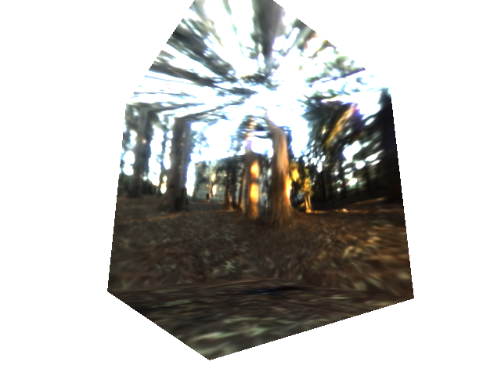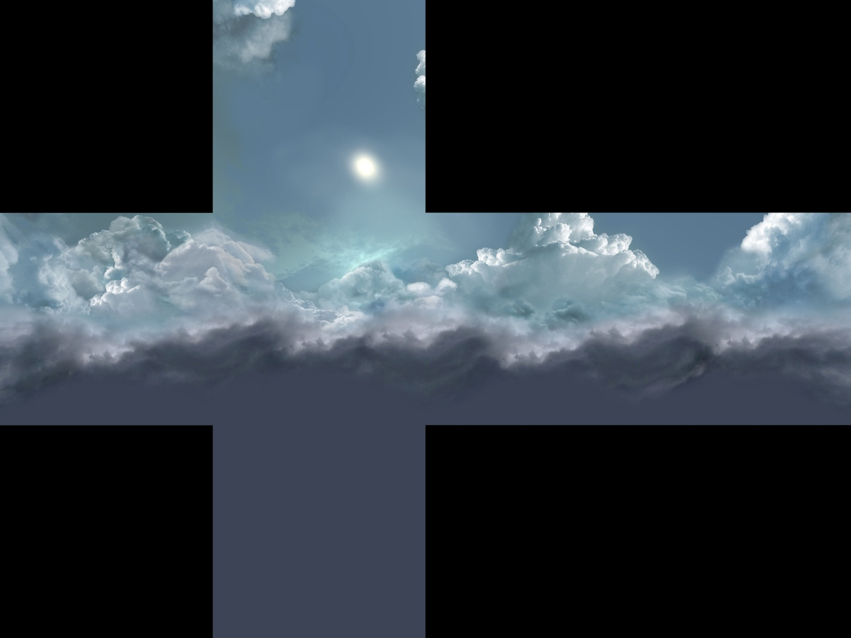

A cube map texture applied to a cube looks like the image on the left. It’s often represent in a cross shape when we’re previewing, which you can imagine folding into a box. We can get a skybox texture (DDS file) by:

- Downloading the “Tutorial 21 - Resources.zip” from myCourse,
- Rendering a scene into a cube map texture at runtime,
- Exporting a cube render from some 3D modelling tools,
- Or Using the DirectX Texture Tool, at...

Start Menu\Programs\Microsoft DirectX SDK (June 2010)\DirectX Utilities (64-Bit)\DirectX Texture Tool (64-Bit)

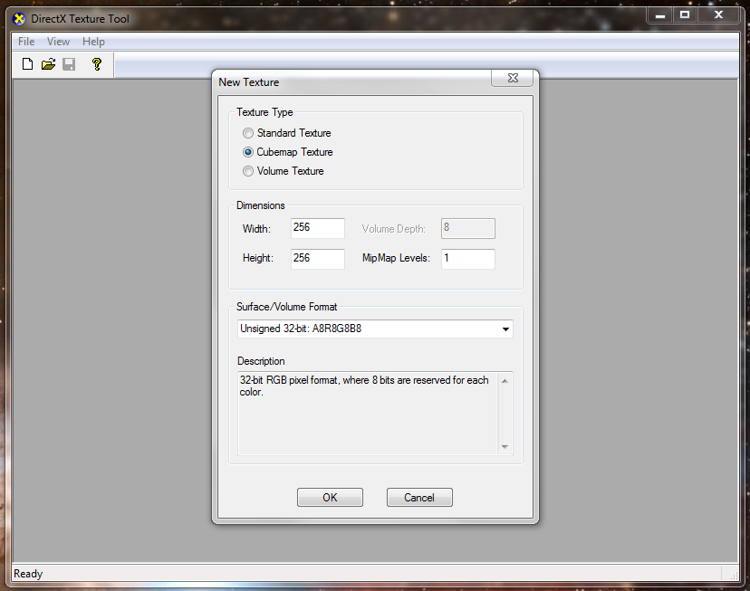

Sky Boxes

We can use a cube map to render the sky in a game. We want the sky to appear infinitely far away, so that we can never reach it. But having a cube surrounding the entire game environment is not always practical as sometimes the environment can be larger than the far plane is from the camera. Instead we want to use a skybox that’s quite small, and move it around the environment so that it’s always centred on the player’s camera.

To do this we need to disable depth writing, and render the inside faces of the cube before the rest of the scene. This way the depth information from the skybox does not block the rendering of anything else.

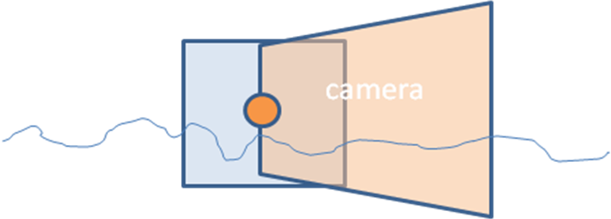

We have already used a cube in the project. The order of the vertices rotation decide which face is the front (visible) face, and the other face is culled – which means the renderer does not attempt to draw it. For this we use a ID3D11DepthStencilState.

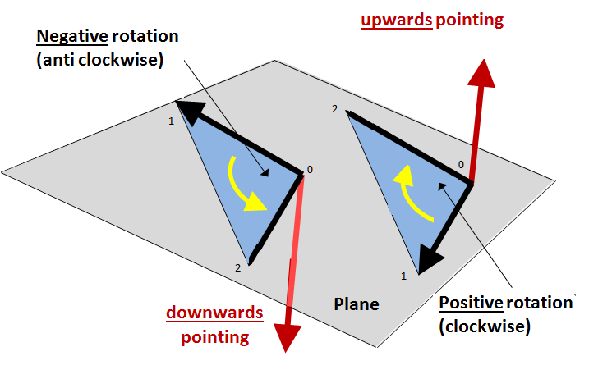
We can still use our same cube, but tell DirectX to change from this default behaviour to show the other, inside face of our existing cube when rendering a skybox. For this we’ll use a ID3D11RasterizerState.

Texture Coordinates

In our shader we define a global TextureCube variable to store the texel information. This is accessed by using a 3D vector. You can think of this as a vector moving outwards from a point at the centre of the cube towards the cubes surface. Where it hits the cube determines the face, and position on that face that we read the texel colour. The length of the vector is not important to DirectX’s HLSL, it will scale the vector as needed. Only the direction matters.

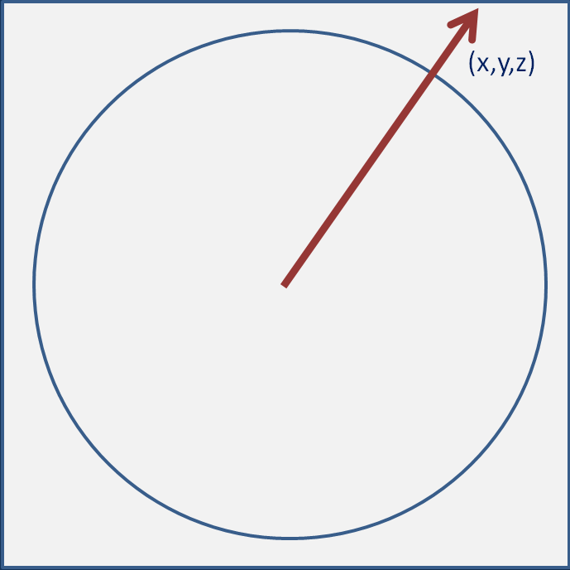

Cube Maps for Reflection Maps

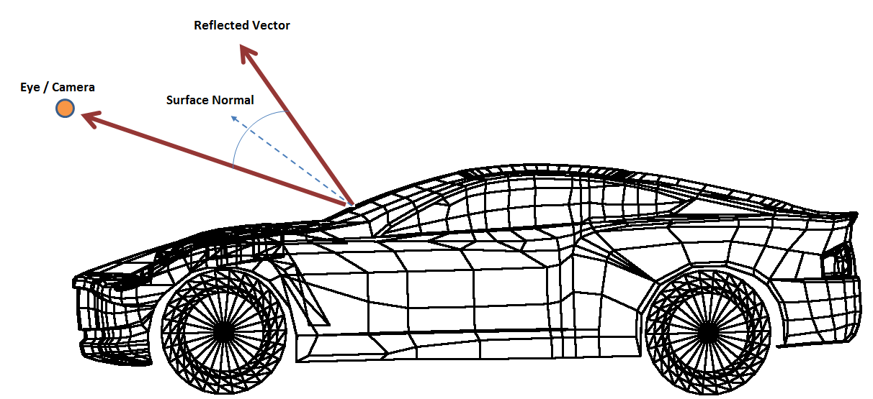

Our triangle normals point perpendicularly away from our triangle surfaces. With the camera position, we can easily calculate a reflected vector. This is equivalent of the rotation from the camera vector to the surface normal, but doubled. The angle of incidence is equal to the angle of reflection.

This gives us a reflected vector, which we can plug into the cubemap to determine which texel to display. As the eye position moves, the reflected vector moves. So the colour at a point on the surface changes, giving us the visual clue that the image on the surface is not a static flat texture.

Exercise 01a – Skybox.

Download the “Tutorial 21 - Resources.zip” from myCourse. Put these textures in the folder with your other assets.

First we’ll render an existing cube and turn it inside out.

1. Make a copy of the code you’ve use to render a cube (in the previous tutorials this is added in RenderFrame. This new code can go in RenderFrame, but try to think about separating it into a new function or class). You’ll need to be setting up a world matrix, setting samplers and textures, and updating the constant buffer with your world matrix, then Drawing.

2. Modify the world matrix for the cube to scale the cube to 3.f (something a little larger than your near plane), and then translates the cube to the camera’s position. Don’t rotate the cube - it will stay axis-aligned.

At this point you should be able to run the program, but you won’t see the cube as the inside faces are being culled.

3. Create new globals (or members of your class).
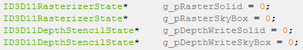

4. Add code to release these objects if the pointers are not zero. These objects will represent a method of rendering. We’ll activate these to tell the renderer to treat our triangles and buffers in different ways.

5. At the initialization stage you’ll need to set these objects using a descriptor. g_pRasterSolid is going to contain the default state of the renderer – the way we’ve always rendered things so far.

Create a local D3D11_RASTERIZER_DESC object. You can find the default values for this structure on MSDN at
https://msdn.microsoft.com/en-us/library/windows/desktop/ff476198(v=vs.85).aspx
(Hint: ZeroMemory can set most of these properties to zero/false for you).

6. Use this to generate a raster state object in g_pRasterSolid. Then modify the CullMode property to front, and create the skybox rasterizer state:

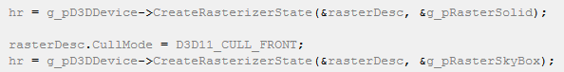

7. Before you Draw the skybox, use the ImmediateContext’s RSSetState function with g_pRasterSkybox. Then after the Draw call, set the state with g_pRasterSolid to restore the default behaviour.

Run the program now and you should see the inside of the cube, which moves with you, but obscures the rest of your scene.

Disable Depth Writing.
The process of setting the depth writing state is very similar to the above.

8. Create a local D3D11_DEPTH_STENCIL_DESC object. You can find the default values for this structure on MSDN at
https://msdn.microsoft.com/en-us/library/windows/desktop/ff476110(v=vs.85).aspx
...but we don’t need to worry about the stencil properties as StencilEnable will be false!

9. Generate a depth-stencil state object in g_pDepthWriteSolid with the relevant default values, using the device’s CreateDepthStencilState function. g_pDepthWriteSkyBox will be the same but with the DepthWriteMask property as D3D11_DEPTH_WRITE_MASK_ZERO.

10. Before you Draw the skybox, use the ImmediateContext’s OMSetDepthStencilState with g_pDepthWriteSkybox, and restore the defaults with Solid afterwards.

Run the program now and you should see the scene rendered over the skybox.

Exercise 01b – CubeMap

1. Create a copy of your shaders.hlsl file used to render the cube. Call this sky_shader.hlsl, and set this up to be used with your skybox cube.

2. We can just pass the worldViewProjection matrix into the constant buffer. As the vertex array for the cube has information for the colour and texcoord, we should continue to use the same stride value and input layout on the C++ side, but we can ignore this extra information in our shader code.

3. Use D3DX11CreateShaderResourceViewFromFile to load one of the skybox DDS textures into a ID3D11ShaderResourceView. Remember to release it too.

4. Set this with PSSetShaderResources alongside your existing sampler before the cube map is drawn.

5. In your sky_shader, declare a cube texture instead of your regular 2D texture with:
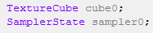
Your vertex shader will need to output a float3 texture coordinate – the unmodified position vector.
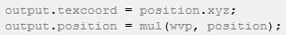

6. Use the .Sample hlsl function as before to sample the texture in your cube map with the float3 texcoord.

You should now see a skybox texture. You can look around inside the skybox, and it moves with you through the environment.

Exercise 02 – Reflection Maps

We’re going to make a reflective version of the sphere model.

1. You can make a copy of your Model class to begin this, and make a copy of the shader called reflect_shader.hlsl for this purpose.

2. Pass the same skybox texture we’ve already used through to a TextureCube in your reflect_shader .

3. You’ll need to pass another matrix into the constant buffer. The worldViewMatrix will be world * view without the projection.

Why: The position passed into our shader comes from the raw model data. We need to modify this so that the vertices are transformed into their position in the world. We also need to know where the camera is, like in the diagram above, so that we can compute the reflection vector. In fact we can concatenate these two things by considering that the camera is the origin of the frustum we are rendering. By using the world * view we can position the model relative to the camera.

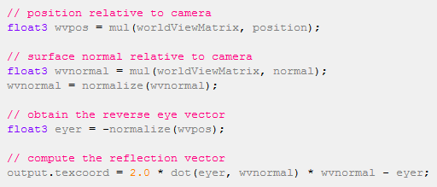

Use this code in your vertex shader to get the position and normal relative to the world view. The last line will calculate the reflected vector. The pixel shader will be almost identical to your sky box.

Additional Exercise – Reflection Maps
Add half of the model’s original 2D texture colour to half of the reflected colour in the pixel shader to give the impression of a polished material.

